MENDMENT TO DEPED ORDER NO. 47, S. 2016, OTHERWISE KNOWN AS THE “OMNIBUS POLICY ON KINDERGARTEN EDUCATION,”

CLARIFYING THAT THE CUT-OFF AGE POLICY IS APPLICABLE TO BOTH PUBLIC AND PRIVATE SCHOOLS AND PROVIDING FOR TRANSITORY PROVISIONS TO ACCOMMODATE KINDER AND GRADE ONE ENROLLEES FOR SY 2018-2019 AND SY 2019-2020 WHO MAY BE AFFECTED BY THIS POLICY, AND FOR OTHER PURPOSES

To:

Undersecretaries  
Assistant Secretaries  
Bureau and Service Directors  
Regional Directors  
Schools Division Superintendents  
Public and Private Kindergarten and Elementary School Heads  
All Others Concerned

1. Republic Act No. (RA) 10157, or the Kindergarten Education Act of 2012, declares that it shall be the policy of the State to provide equal opportunities for all children to avail of accessible mandatory and compulsory kindergarten education.

2. RA 10157 and RA 10533, or the Enhanced Basic Education Act of 2013, provide that kindergarten education shall mean “one year of preparatory education for children at least five (5) years old as a prerequisite for Grade 1.”

3. The Department of Education (DepEd) is vested, under RA 10157, with the authority to regulate the organization, operation and/or implementation of the kindergarten education program of both public and private schools. The DepEd is further charged with the function to oversee and supervise the organization, operation and implementation of the kindergarten education program and exercise authority over the operation of private kindergarten institutions.

4. The kindergarten curriculum is designed to respond to the holistic developmental needs of five (5) year old learners along socio-emotional, values, physical health and motor, aesthetic/creative, mathematics, understanding of the physical and natural environment, language, literacy, and communication. Moreover, the first quarter of the curriculum is designed to strengthen the learners’ preparation to meet the Kindergarten learning standards.

5. In view of the foregoing considerations, the Department hereby issues this Order clarifying the applicability of DepEd Order No. 47, s. 2016, or the [Omnibus Policy on Kindergarten Education](https://www.teacherph.com/omnibus-policy-kindergarten-education/), to both public and private schools, thereby amending said Order to read as follows:

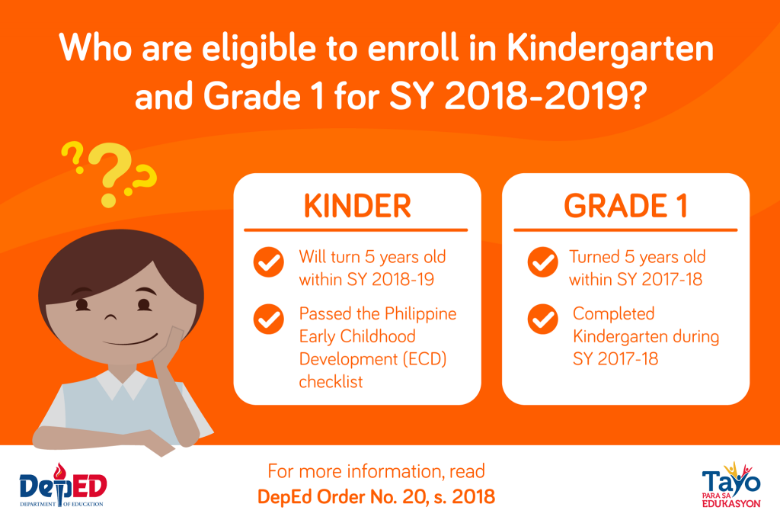

A. Item VI. 15.A of the enclosure to DepEd Order No. 47, s. 2016 is hereby amended to read as follows:

**“VI. Enrolment Procedures**

15. All Regional Directors, Schools Division Superintendents, and School Heads of both public and private schools are directed to accept children in accordance with the following guidelines:

A. Age qualification for Kindergarten learners in **both public and private schools** should be five (5) years old by June 1 of every calendar year. However, the school may consider learners entering Kindergarten who will turn five (5) years old by the end of August on the condition that the **Philippine Early Childhood Development (ECD) Checklist** must be administered to the learner prior to the start of the opening of the school year, to ensure that the learner is capable of meeting the expectations of the grade level. Parents may provide documentation and/or certification of the learner’s previous Early Childhood Education (ECE) experiences (i.e., preschool, day care, pre-Kindergarten) in addition to the results of the Philippine ECD Checklist.

**For schools commencing their school year beyond June, the requirement that Kindergarten learners should be five (5) years old by June 1 and the extension period ending on August 31 shall be adjusted. For schools commencing their school year in July, Kindergarten learners should be five (5) years old by July 1 and the extension period shall be until September 30. For schools commencing their school year in August, Kindergarten learners should be five (5) years old by August 1 and the extension period shall be until October 31.”**

MORE FROM TEACHERPH

[DEPED ORDER](https://www.teacherph.com/category/issuances/deped-order/)

[Early Language Literacy and Numeracy Program Funds](https://www.teacherph.com/early-language-literacy-and-numeracy-program-funds/)

May 23, 2018

[DEPED ORDER](https://www.teacherph.com/category/issuances/deped-order/)

[Promotion and Compensation of all ALS Implementers](https://www.teacherph.com/promotion-compensation-als-implementers/)

May 18, 2018

[DEPED ORDER](https://www.teacherph.com/category/issuances/deped-order/)

[DepEd School Calendar for School Year 2018-2019](https://www.teacherph.com/deped-school-calendar-2018-2019/)

May 16, 2018

[DEPED ORDER](https://www.teacherph.com/category/issuances/deped-order/)

[Flexible Working Hours of DepEd Non-Teaching Personnel](https://www.teacherph.com/deped-non-teaching-personnel-working-hours/)

May 11, 2018

B. To recognize the right of private schools to impose additional requirements that are consistent with existing laws, rules and regulations, a new Item VI.15.E is hereby added to the enclosure to DepEd Order No. 47, s. 2016, which shall read as follows:

**“E. Private schools may impose special or additional admission requirements that are consistent with their right to operate as a private school as provided for under existing laws, rules and regulations. Such additional requirements may include, but not limited to the following:**

**i. passing of an entrance or qualifying examination;**

**ii. completing an additional pre-kindergarten program at an earlier age;**

**iii. passing other kindergarten readiness tools that such private schools may administer; and**

**iv. such other requirements that private schools may impose not contrary to existing laws, rules and regulations to maintain such private schools’ standards.”**

C. To accommodate Kinder and Grade One enrollees in both public and private schools for School Year (SY) 2018-2019 and SY 2019-2020 who may be affected by this policy, the following transitory provisions are herein provided:

**(1) For SY 2018-2019:**

i. Learners who completed Kindergarten during SY 2017-2018 can enroll in Grade 1, provided that they turned five (5) years old within SY 2017-2018;

ii. Learners who will turn five (5) years old within SY 2018-2019 can be accepted to Kindergarten provided they pass the Philippine Early Childhood Development (ECD) checklist.

**(2) For SY 2019-2020:**

i. Learners who completed Kindergarten during SY 2018-2019 can enroll in Grade 1, provided that they turn five (5) years old within SY 2018-2019 when they complete Kindergarten;

ii. Incoming Kindergarten must strictly comply with the cut-off age policy stated in DO No. 47, s. 2016, as amended by this DepEd Order.

**(3) For SY 2020-2021**

Both incoming Kindergarten and Grade 1 learners shall strictly comply with the policy as stated under Item VI. 15.A of the enclosure to DepEd Order No. 47, s. 2016, as amended by this DepEd Order.

6. DepEd Order No. 47, s. 2016, Memorandum No. DM-CI-2017-00454 dated 11 December 2017 entitled *Clarificatory Guidelines on the Provisions of DepEd Order No. 47, s. 2016 “Omnibus Policy on Kindergarten Education”,* DepEd Order No. 3, s. 2018, and all other DepEd Orders, mles, regulations, issuances, which are inconsistent with this Order, are hereby repealed or modified accordingly.

7. These guidelines shall take effect immediately.

8. Immediate dissemination of and strict compliance with this Order is directed.

**LEONOR MAGTOLIS BRIONES**  
Secretary

[deped order](https://www.teacherph.com/tag/deped-order/)[ECD Checklist](https://www.teacherph.com/tag/ecd-checklist/)[grade 1](https://www.teacherph.com/tag/grade-1/)[kindergarten](https://www.teacherph.com/tag/kindergarten/)[Philippine Early Childhood Development (ECD) Checklist](https://www.teacherph.com/tag/philippine-early-childhood-development-ecd-checklist/)

**[14](https://www.teacherph.com/cut-off-age-kinder-grade-one/" \l "comments" \o "Leave a comment on: \“Cut-Off Age Policy for Kinder and Grade One Enrollees\”)**

**Share**[Facebook](https://www.facebook.com/sharer.php?u=https%3A%2F%2Fwww.teacherph.com%2Fcut-off-age-kinder-grade-one%2F" \t "_blank)[Twitter](https://twitter.com/share?text=Cut-Off+Age+Policy+for+Kinder+and+Grade+One+Enrollees%20@teacherph&url=https%3A%2F%2Fwww.teacherph.com%2Fcut-off-age-kinder-grade-one%2F" \t "_blank)[Google+](https://plus.google.com/share?url=https%3A%2F%2Fwww.teacherph.com%2Fcut-off-age-kinder-grade-one%2F" \t "_blank)

[Mark Anthony Llego](https://www.teacherph.com/author/llego-xyz/)

He is the brain of TeacherPH. Growing up being surrounded by educators, a passion for education has grown in him. Mark spends his time writing and spreading online articles about the educational world. He likes emphasizing important political issues that involves issued on the educational system of the country. [Join Our Facebook Discussion Group](https://www.facebook.com/groups/teacherph/)

[YOU MIGHT ALSO LIKE](https://www.teacherph.com/cut-off-age-kinder-grade-one/" \l "relatedposts_315459033_1)[More From Author](https://www.teacherph.com/cut-off-age-kinder-grade-one/" \l "relatedposts_315459033_2)

[DEPED ORDER](https://www.teacherph.com/category/issuances/deped-order/)

[School Readiness Year-End Assessment (SReYA)](https://www.teacherph.com/school-readiness-year-end-assessment-sreya/" \o "School Readiness Year-End Assessment (SReYA))

[DEPED ORDER](https://www.teacherph.com/category/issuances/deped-order/)

[DepEd School Sports Program](https://www.teacherph.com/deped-school-sports-program/" \o "DepEd School Sports Program)

[DEPED ORDER](https://www.teacherph.com/category/issuances/deped-order/)

[Implementation of School-Based Feeding Program for Fiscal Year 2018](https://www.teacherph.com/school-based-feeding-program-2018/" \o "Implementation of School-Based Feeding Program for Fiscal Year 2018)

 PREV NEXT

LEAVE A REPLY

Top of Form

**Connect with:**

[Login With Facebook](https://www.teacherph.com/wp-login.php?action=wordpress_social_authenticate&mode=login&provider=Facebook&redirect_to=https%3A%2F%2Fwww.teacherph.com%2Fcut-off-age-kinder-grade-one%2F)

Your email address will not be published.







Save my name, email, and website in this browser for the next time I comment.



Bottom of Form

14 COMMENTS

Ehrene Says 1 month ago

My Son is 5 yrs old and completed the Pre-SChool Education S.Y. 2017-2018 He also completed his day care education SY 2017-2018. Supposedly he will be Grade 1 now. But he will not be accepted because daan muna ng Kinder. kasi affected sa cutoff age before? What is the best thing to do? I will enrol him in Grade 1 pero he will not be accepted because walang LRN. He will turn 6 years old thin november 6, 2018 .Sana naman po bigyan ng kasagutan! kasi sayang ang pera at panahon.

[Reply](https://www.teacherph.com/cut-off-age-kinder-grade-one/" \l "comment-18687)

Marian D. Nicdao Says 2 months ago

Since this Amendment was issued last April 21, 2018 and according to the School they just received it by May 2018. Hindi na po nila na inform yung mg parent ng students na 5yrs old for SY2018~2018. Possible ba na i Grade 1 yung child kahit natapos lang niya Nursery and Kindergarten Junior? Ano requirement

[Reply](https://www.teacherph.com/cut-off-age-kinder-grade-one/" \l "comment-18573)

Arwen Says 3 months ago

Required po na mag kinder ang bata bago pumasok ng grade 1

[Reply](https://www.teacherph.com/cut-off-age-kinder-grade-one/" \l "comment-18457)

Nats To Says 3 months ago

This is a good info .. will be curious to also know if the cut off is only for entry age… is there a max age requirement too ? ( e.g. the kid is delayed ) I have been hearing that there is also a max age for each level and they will force the family to go up a level ( head straight to grade 1 ) if they are of certain age. Will be curious to get insights on this item

[Reply](https://www.teacherph.com/cut-off-age-kinder-grade-one/" \l "comment-18454)

Gina Eslera Says 3 months ago

“Learners who completed Kindergarten during SY 2017-2018 can enroll in Grade 1, provided that they turned five (5) years old within SY 2017-2018” – how can learners complete kindergarten for SY 2017-2018 when the system only accepts those who will turn 5 years old as of August 2017?

[Reply](https://www.teacherph.com/cut-off-age-kinder-grade-one/" \l "comment-18453)

Vic Lavisto Says 3 months ago

This is a good amendment.. But there are cases that a child has already mastered kindergarten abilities at d age of 3 and 4 and has already completed one kindergarten class. Can it be an another consideration to accept d child in Grade1? I hope for some revisions on this policy in favor of my query. Thanks

[Reply](https://www.teacherph.com/cut-off-age-kinder-grade-one/" \l "comment-18446)

Gievancastillo Says 3 months ago

My son had completed kinder garden at the age of 3-4 years old, entered Grade 1 at age of 5. Now, he is a 4th year College at age of 18, taking up BSCivil Engineering. Thanks God! sa mahal ng tuition fee ngayon at may K-to12 pa dina naabutan ng anak ko..:)

[Reply](https://www.teacherph.com/cut-off-age-kinder-grade-one/" \l "comment-18461)

Joy Says 3 months ago

Sir my daughter will turn 5 years old on september 24, 2018 and just finished her junior kindergarten this last school year is it possible that she’ll be admitted as a senior kinder garten this school year 2018-2019? Thank you

[Reply](https://www.teacherph.com/cut-off-age-kinder-grade-one/" \l "comment-18445)

Khristine Bermundo Says 3 months ago

hello po my son will turn 5years old this september 25,2018.. nakapag pre kinder na po siya ma accept po ba sya for kinder 2?thankyou po!:)

[Reply](https://www.teacherph.com/cut-off-age-kinder-grade-one/" \l "comment-18451)

Barbie Cerda Says 3 months ago

My daughter is 5years old and had already taken her pre-kinder last SY 2017-18. Question is will she be enroll as Grade 1 student or Kinder level for this coming SY 2018-19?

[Reply](https://www.teacherph.com/cut-off-age-kinder-grade-one/" \l "comment-18442)

[Mark Anthony Llego](https://www.teacherph.com/) Says 3 months ago

Good Morning!

RA No. 10157, or the Kindergarten Act, Institutionalizes Kindergarten as part of the basic education system and is a pre-requisite for admission to Grade 1.

[Reply](https://www.teacherph.com/cut-off-age-kinder-grade-one/" \l "comment-18443)

Marisse Says 3 months ago

Learners who completed Kindergarten during SY 2017-2018 can enroll in Grade 1, provided that they turned five (5) years old within SY 2017-2018” – how can a child complete kindergarten for SY 2017-2018 when he was denied by the system during SY 2017-2018 enrolment? the child was born Sept 2012 and what they have accepted for enrolment were those born June 2012-Aug 2012 only. Will DEPEd requires the private schools in Baguio City to require for a qualifying exams to those children who were not able to enroll in Kinder and want to enroll now in Grade1? Hope u consider this… Thanks

[Reply](https://www.teacherph.com/cut-off-age-kinder-grade-one/" \l "comment-18465)

Marian D. Nicdao Says 2 months ago

Hi Sir Marisse ,  
May nag reply na ba sa comment mo? Pa share naman

[Reply](https://www.teacherph.com/cut-off-age-kinder-grade-one/" \l "comment-18574)

Jessel Nudo Says 2 months ago

Hi Ms Marisse and Marian, I have same concern as yours.My son turned 5 last September 4, 2017. He was beyond the cut-off which is August 31 so he can’t enroll yet for Kindergarten. He was not accepted to Kindergarten so we enrolled him on Day Care Center. Now, DepEd has this new amendment, my child can’t enroll again for Grade 1 bec. he has no LRN (Learner’s Reference Number) which is only available for those who took up Kindergarten. Napakamisleading po ng policies ng DepEd. Dapat maging consistent kayo para hindi nasasayang ung isang taon na sana ginugol niya for Kinder or Grade 1 na.Sana iconsider ung assessment niya from Day Care Center if he is.qualified for Grade 1 even without the LRN,

Top of Form



Bottom of Form

 RECENT POSTS

* [Do Public School Teachers have the Right to Strike?](https://www.teacherph.com/teachers-right-to-strike/)
* [What To Do If You Have A Math Test Tomorrow And You Don’t Even Open A Book?](https://www.teacherph.com/math-test-tomorrow/)
* [2017 Principals’ Test Top Ten Passers](https://www.teacherph.com/2017-principals-test-top-ten-passers/)
* [The Public School Class Size Law of 2016 (House Bill 473)](https://www.teacherph.com/public-school-class-size-house-bill-473/)
* [Tobacco company-funded donations for Brigada prohibited](https://www.teacherph.com/tobacco-company-funded-donations/)

 RECENT COMMENTS

* Rebecca A. Aroña on [DepEd Requirements for Transfer of Teachers to Another School](https://www.teacherph.com/deped-requirements-transfer-teachers-another-school/" \l "comment-19164)
* GINA AXALAN BAYTA on [DepED Learner Information System (LIS) User’s Guide](https://www.teacherph.com/deped-learner-information-system-users-guide/" \l "comment-19157)
* rinalyn on [Filipino LET Online Reviewer](https://www.teacherph.com/filipino-let-online-reviewer/" \l "comment-19154)
* ligaya on [Downloadable Resources](https://www.teacherph.com/teacherph-downloadable-resources/" \l "comment-19148)
* reia pacheco on [Philippine Normal University](https://www.teacherph.com/philippine-normal-university-professional-education-reviewer/" \l "comment-19143)